**COVID TEST**

**&**

**VACCINATION SYSTEM**

**PROJECT GROUP MEMBERS**

|  |  |
| --- | --- |
| Students id | Students name |
| **Student1449388** | **Muhammad Ahsan** |
| **Student1449717** | **Muhammad Mohsin Mukhtiar** |
| **Student1444862** | **Fareeha** |
| **Student1429148** | **Marfia Rani** |

**CURRICULUM BATCH**

**7062 2301B2**

**FACULTY**

**SIR HARIS NASEER**

**CO-ORDINATOR**

**MISS MAHA**

**Certificate**

This is to certify that the dissertation entitled **“VACCINATION BOOKING SYSTEM”** is **Muhammad Mohsin Student 1449717 ,**

**Fareeha Student 1444862,**

**Marfia Rani Student 1429148**

**MUHAMMAD Ahsan Student 1449388,**

in their partial fulfilment of the requirement of the award of the Aptech Computer Certified.

**Acknowledgement**

The success and final outcome of this project required a lot of guidance and assistance from many people and I am extremely privileged to have got this all along the completion of my project. All that I have done is only due to such supervision and assistance and I would not forget to thank them.

I respect and thank Aptech for providing me an opportunity to do the project work in ACE and giving us all support and guidance, which made me complete the project duly. I am extremely thankful to Aptech for providing such a nice support and guidance.

I owe my deep gratitude to our project guide **SIR HARIS NASEER**, who took keen interest on our project work and guided us all along, till the completion of our project work by providing all the necessary information for developing a good system.

Student1449717 Muhammad Mohsin Student1444862 Fareeha Student1429148 Marfia Rani Student1449388 Muhammad Ahsan

**Abstract**

**DocCure Vaccination System is a user-friendly online platform that simplifies and enhances the vaccination process for both healthcare providers and recipients. In response to global health challenges, DocCure aims to connect healthcare professionals with the community, offering a secure and accessible digital solution. The platform features centralized appointment scheduling, personalized immunization records, automated reminders, and real-time updates on vaccine availability. With a commitment to secure data management and a focus on community health, DocCure strives to contribute to a healthier society by promoting accessibility, awareness, and efficiency in immunization services**.

**INTRODUCTION**

**The thirst for learning, upgrading technical skills and applying the concepts in**

**real life environment at a fast pace is what the industry demands from IT**

**professionals today. However busy work schedules, far-flung locations,**

**unavailability of convenient time-slots pose as major barriers when it comes to**

**applying the concepts into realism. And hence the need to look out for**

**alternative means of implementation in the form of laddered approach.**

**The above truly pose as constraints especially for our students too! With their**

**busy schedules, it is indeed difficult for our students to keep up with the genuine**

**and constant need for integrated application which can be seen live especially so**

**in the field of IT education where technology can change on the spur of a**

**moment. Well, technology does come to our rescue at such times!!**

**Keeping the above in mind and in tune with our constant endeavour to use**

**Technology in our training model, we at Aptech have thought of revolutionizing**

**the way our students learn and implement the concepts using tools themselves**

**by providing a live and synchronous eProject learning environment!**

**So what is this eProject?**

**eProject is a step by step learning environment that closely simulates the**

**classroom and Lab based learning environment into actual implementation. It is a**

**project implementation at your fingertips!! An electronic, live juncture on the**

**machine that allows you to**

**• Practice step by step i.e. laddered approach.**

**• Build a larger more robust application.**

**• Usage of certain utilities in applications designed by user.**

**• Single program to unified code leading to a complete application.**

**• Learn implementation of concepts in a phased manner.**

**• Enhance skills and add value.**

**• Work on real life projects.**

**• Give a real life scenario and help to create applications more**

**complicated and useful.**

**• Mentoring through email support.**

**The students at the centre are expected to complete this eProject and send**

**complete documentation with source code to eProjects Team**

**Looking forward to a positive response from your end!!**

# REQUIREMENTS

# System Modules:

# Admin

# • All child details

# • Date &amp; time of vaccination

# • Report of vaccination

# o Child, Vaccination (Date wise report)

# • List of vaccine

# o available or unavailable

# • Request from parents

# o Approve or Reject

# • Add Hospital

# o Update/Delete Hospital

# • List of hospitals

# • Booking Details

# Parent

# • Register &amp; Login

# • Details of child

# • Vaccination Dates

# • Book Hospital

# • Request for hospital

# • Report of vaccination taken

# • My profile

# Hospital

# • Register & login

# • Update Vaccine status

**REQUIREMENT** **SPECIFICATION**

**Modules Description**

**Admin**

**• All child details**

**o View all child profile details**

**• Date of vaccination**

**o Upcoming Date of vaccination of all child**

**• Report of vaccination**

**o Child, Vaccination (Date wise report)**

**• List of vaccine**

**o available or unavailable**

**o Admin can view the availability of the vaccination**

**• Request from parents**

**o Approve or Reject**

**o Once the request for appointment from parent side, it will be approved from the**

**admin**

**• Add Hospital**

**o Admin can add the hospital details**

**• Update/Delete Hospital**

**o Admin can update or delete the hospital details**

**• List of hospitals**

**o Admin can view the hospital details**

**• Booking Details**

**o Admin can view the booking details from parent side for booking vaccination**

**Parent**

**• Details of child**

**o Update and maintain the child details of vaccination**

**• Vaccination Dates**

**o Can get notified through in Dashboard of their respective accounts about upcoming**

**vaccinations.**

**• Book Hospital**

**o Use can search the list of hospital and book schedule for the vaccine dates**

**• Report of vaccination taken**

**o Can get the report status of previous vaccination of their respective Infants**

**Hospital**

**• Register &amp; Login**

**o Can register and login into the app with hospital name, address and location details.**

**• Update Vaccine status**

**o Hospital will receive the appointment once its booked from admin side. If**

**vaccination is completed they will update the status to Vaccinated or not.**

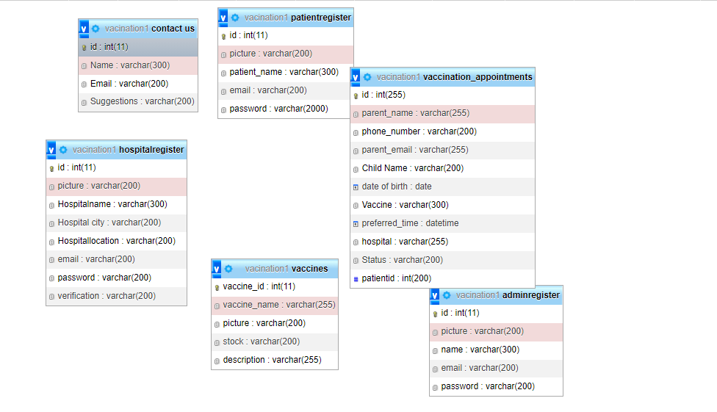 **DIAGRAM**

**ADMIN**

**SCREENSHOTS**

## LOGIN

## 

## HEADER

**SIDEBAR**

## 

**HOME**

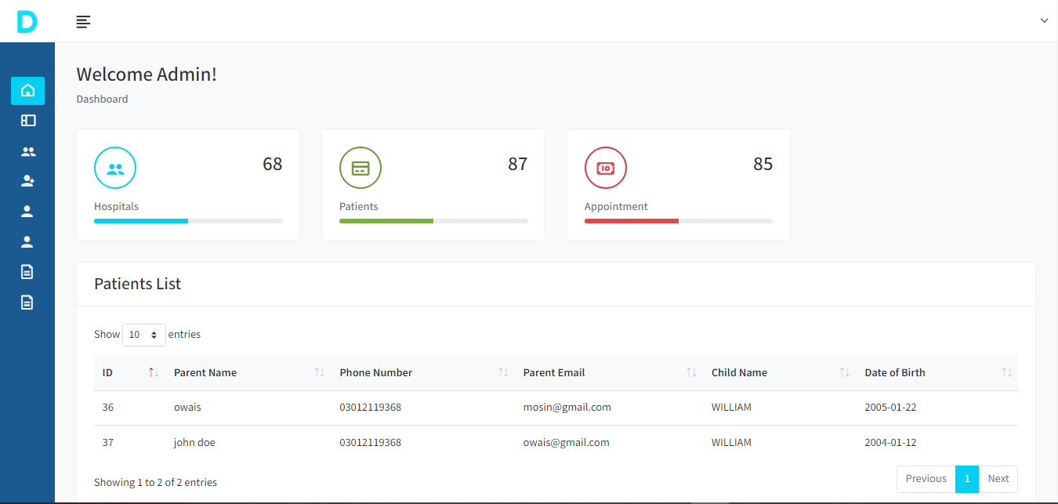

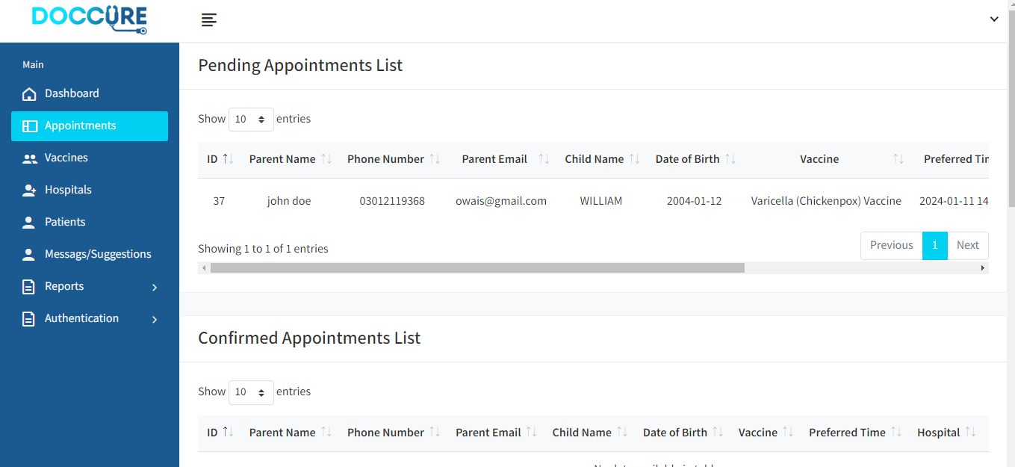 **APPOINTMENT VIEW**

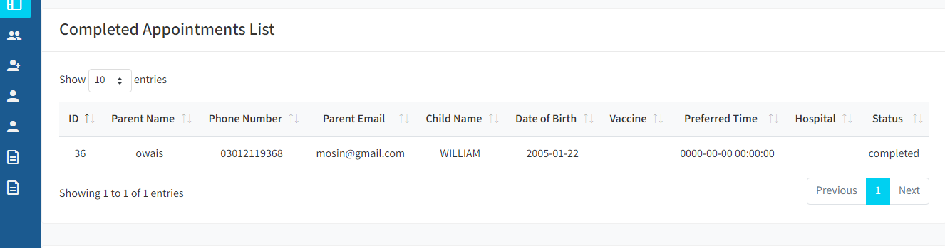**VACCINE COMPLETE VIEW**

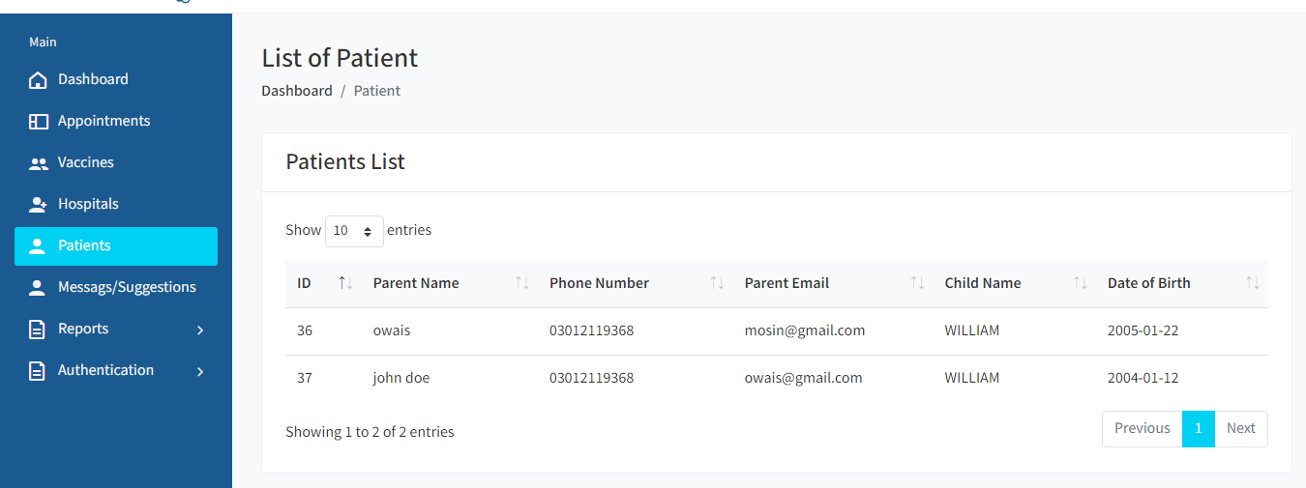**PATIENTS VIEW**

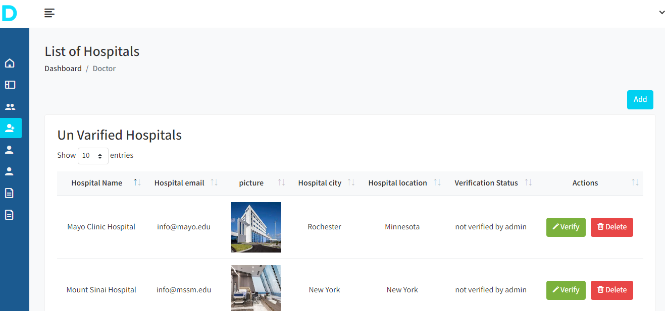**HOSPITALS VIEW**

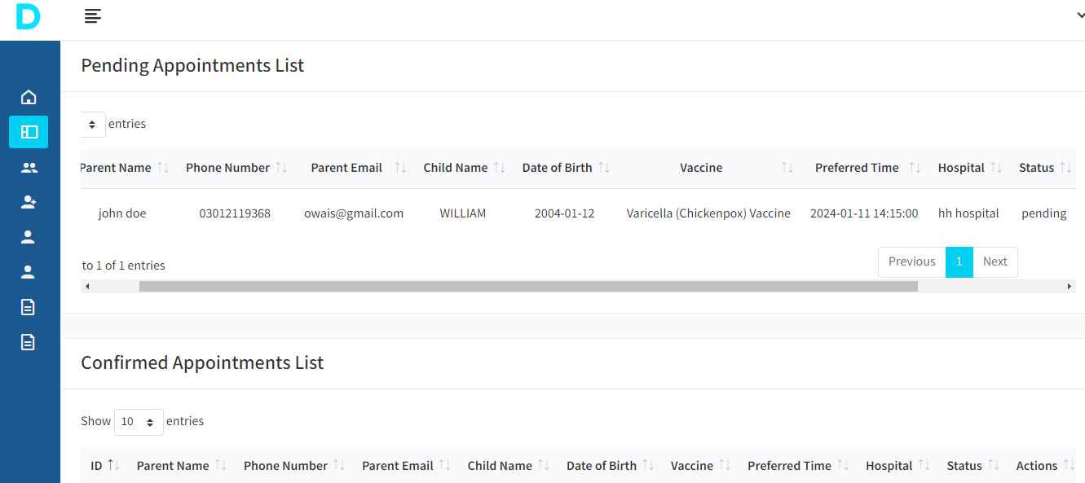**APPOINTMENT VIEW**

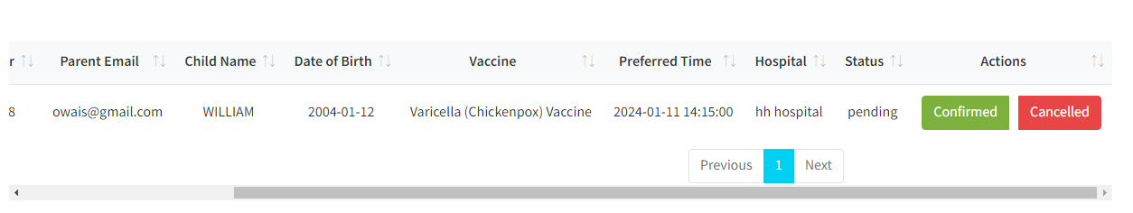**APPROVE APPOINTMENT**

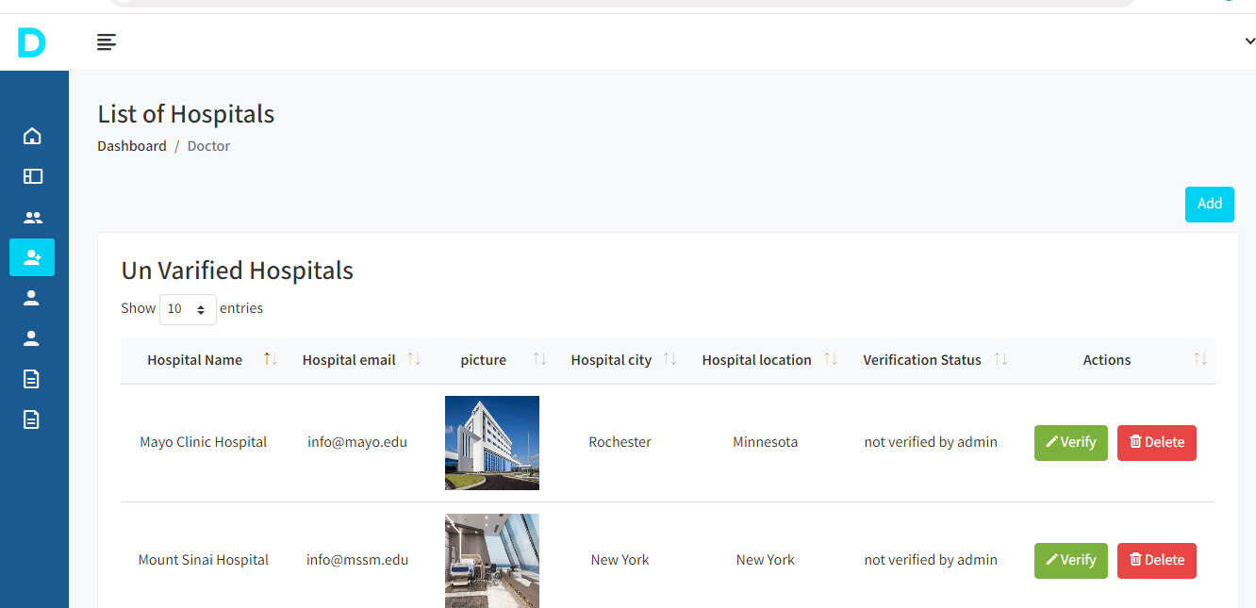**APPROVE HOSPITAL**

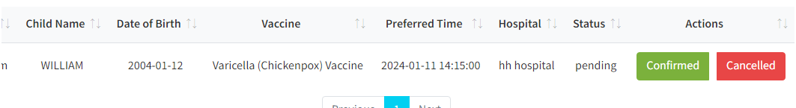**REJECT APPOINTMENT**

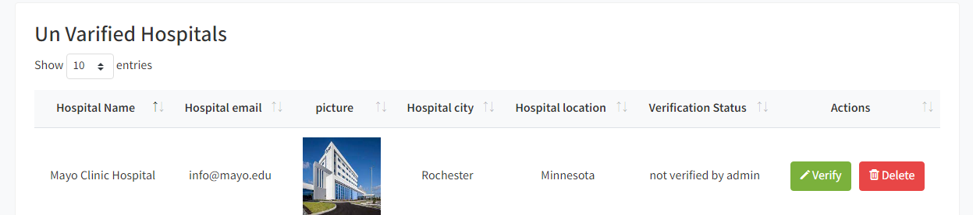 **REJECT HOSPITAL**

**PATIENT**

**SCREENSHOTS**

**HEADER**

**FOOTER**

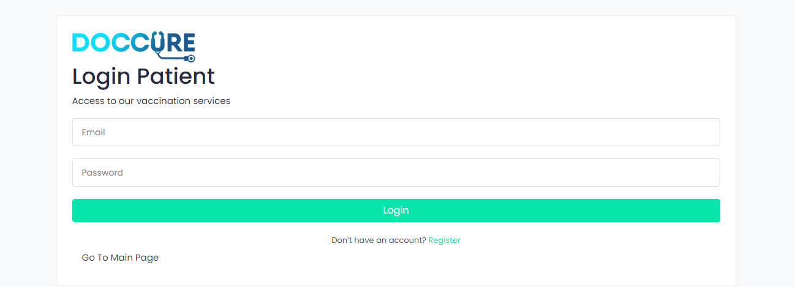**LOGIN**

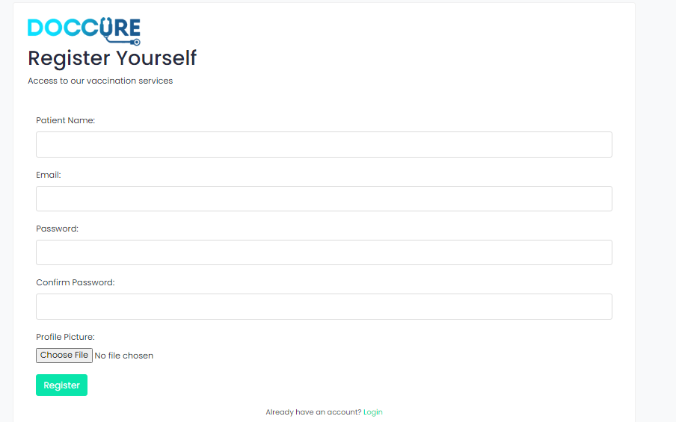**REGISTER**

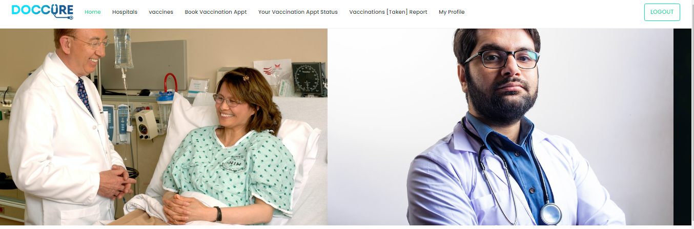**HOME**

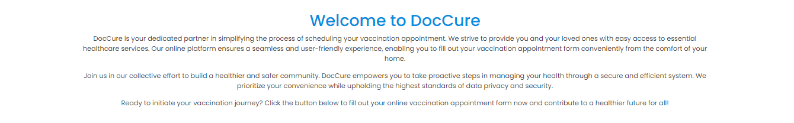**ABOUT**

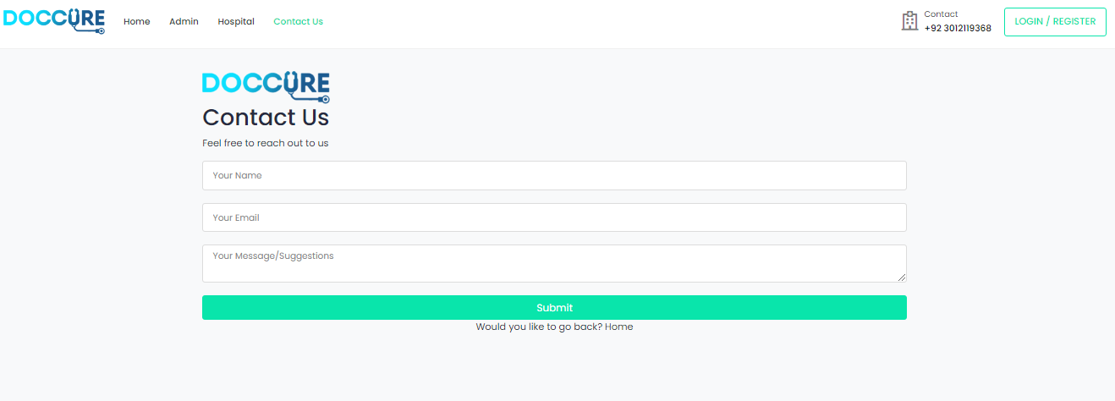**CONTACT US**

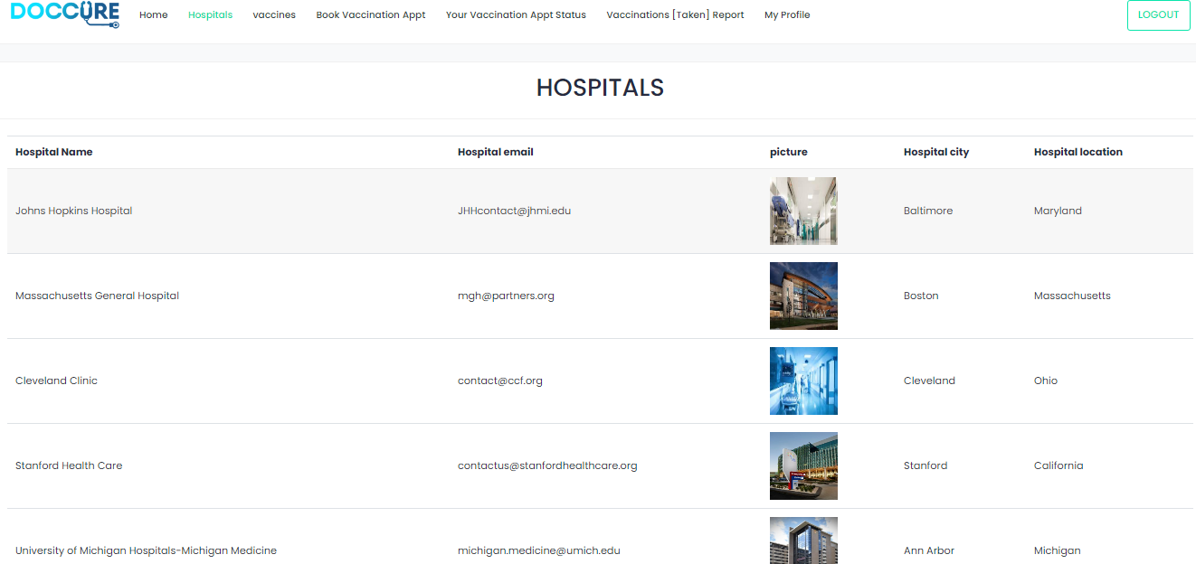**HOSPITALS**

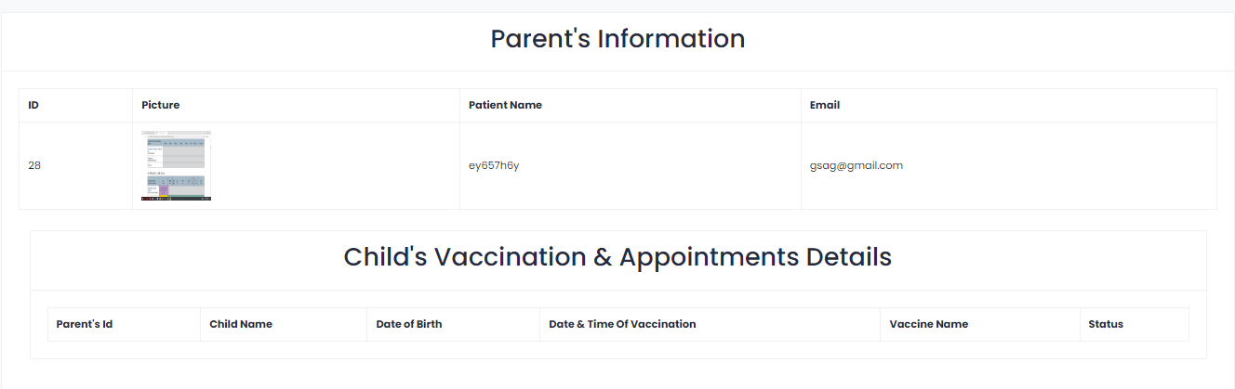**USER PROFILE**

**VIEW APPIONTMENT**

**STATUS**

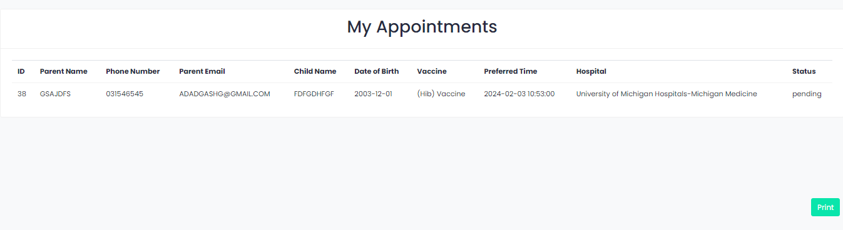

**BOOK APPOINTMENT**

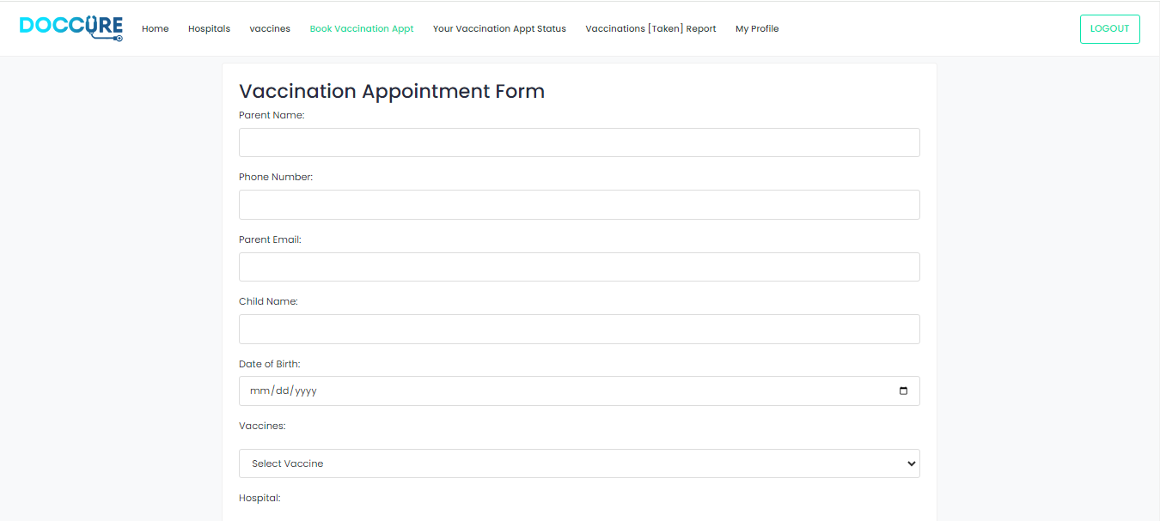

**HOSPITAL**

**SCREENSHOTS**

**HEADER**



**LOGIN**

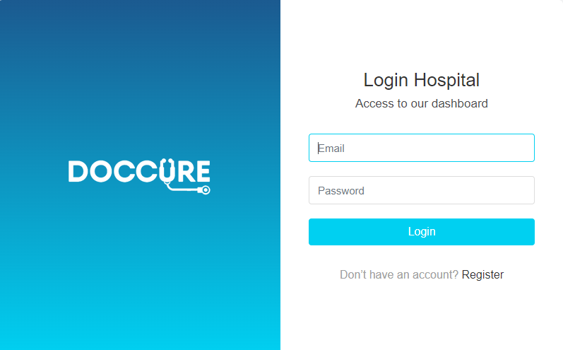

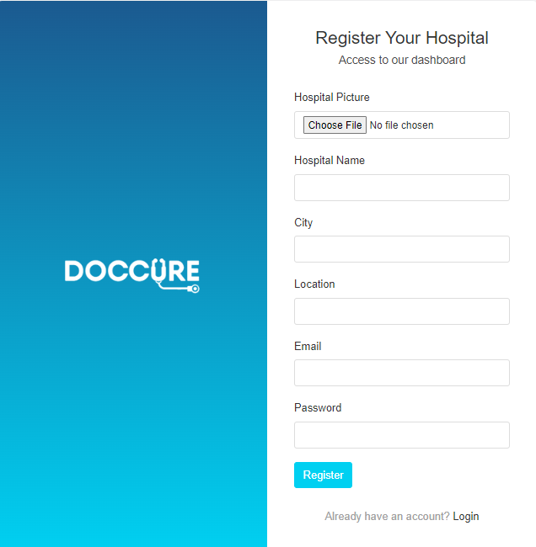**REGISTER**

**HOME**

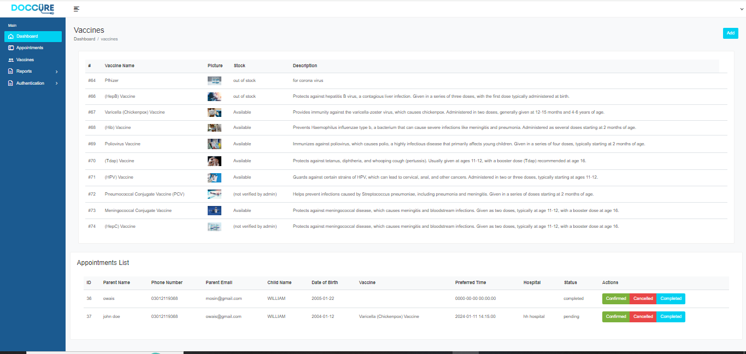

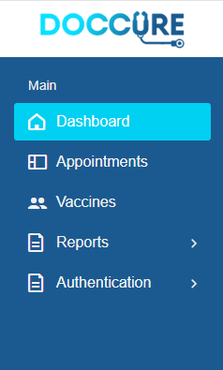**SIDEBAR**

**APPOINTMENTS**

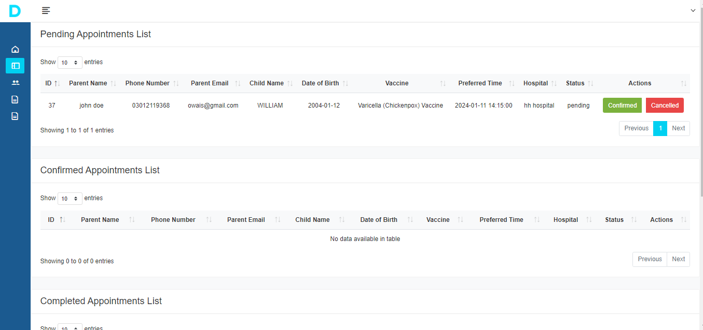

**CONFIRM/CENCEL APPOINTMENTS**



**REPORTS**

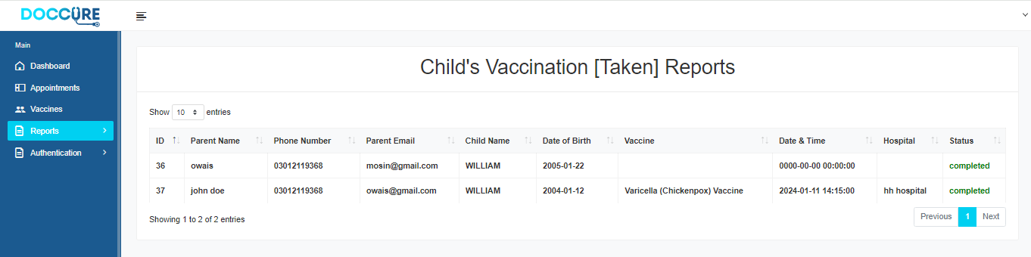

**ALL APPTS LIST**

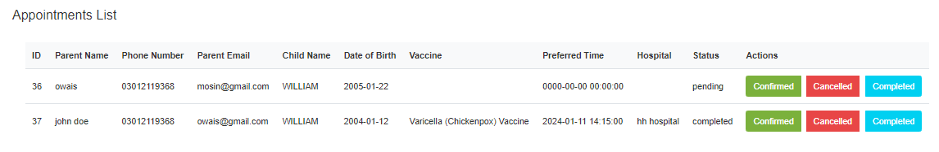

**CONFIRM/CENCEL/COMPLETE APPT**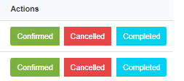

**PENDING APPT LIST**

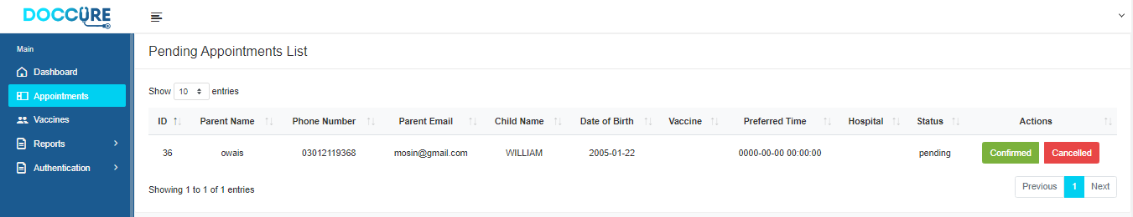

**CONFIRMED APPT LIST**

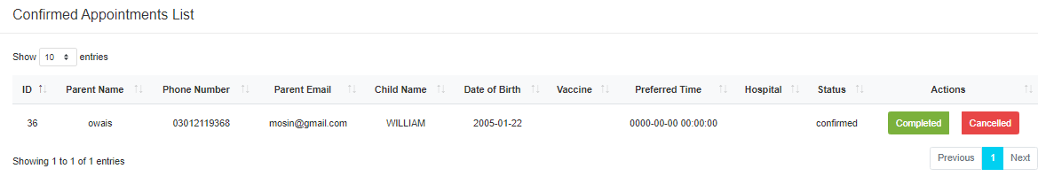

**CENCELED APPT LIST**

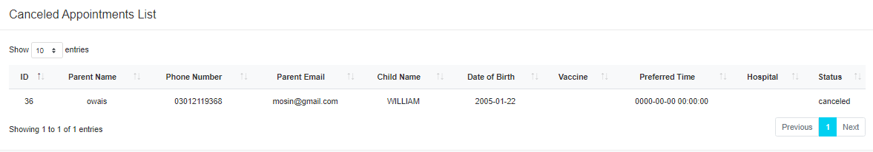

# Conclusion

**A covid test & vaccination system has been developed and the system was tested with sample data. The system results in regular timely preparations of required outputs. Provision for addition and deletion of customers is there in the system it is possible to view that proper filling system has been adopted to slate date for future. The entire project runs on windows environments. The system can be used to make better management described at appropriate time. The user gets amount and timely information system.**

**THANK YOU!**